Name: Devasy Patel

Roll No.: 20BCE057

Subject: Computer Network

Subject Code:2CS502

Practical: 1

Aim: Use of CN , connecting devices, networks and their types, network standards. Network hardware, network software, OSI , and TCP/IP Ref Model.

Step1: Select taking 2 end-devices

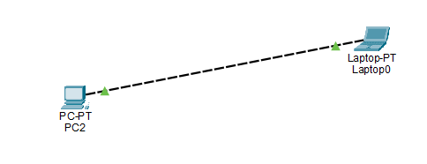

Step2: setting up connection between 2 end-devices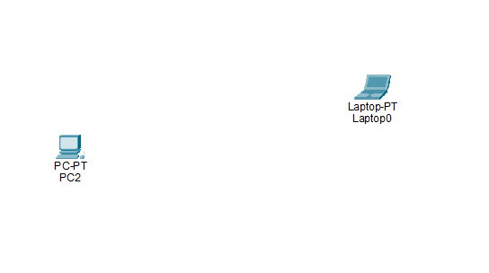

Step3: setting up IP address of end device 1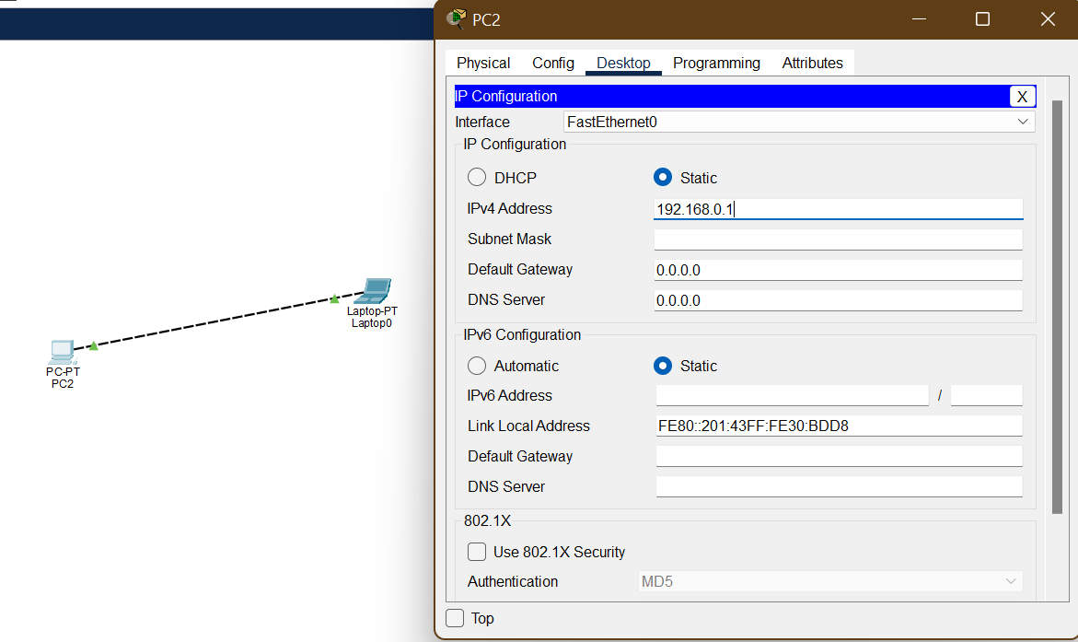

Step4: setting up IP address of end device 2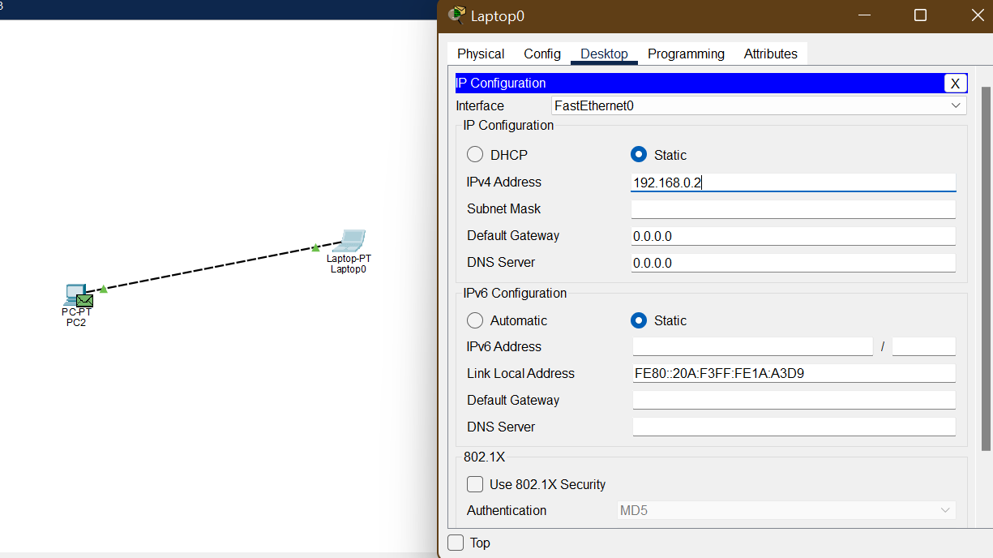

Step5: ping end device 1 from end device 2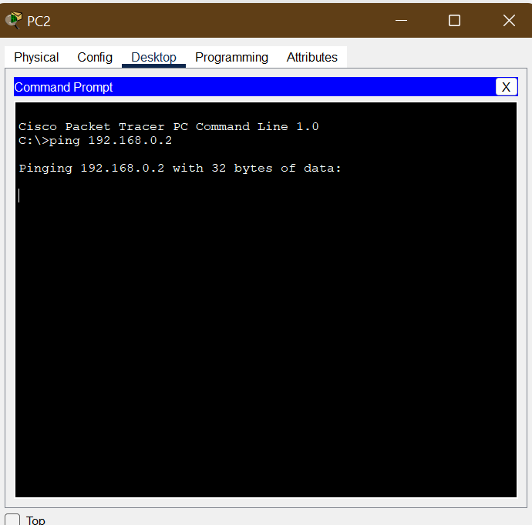

Step6: see the message received on end device 1 by the ping